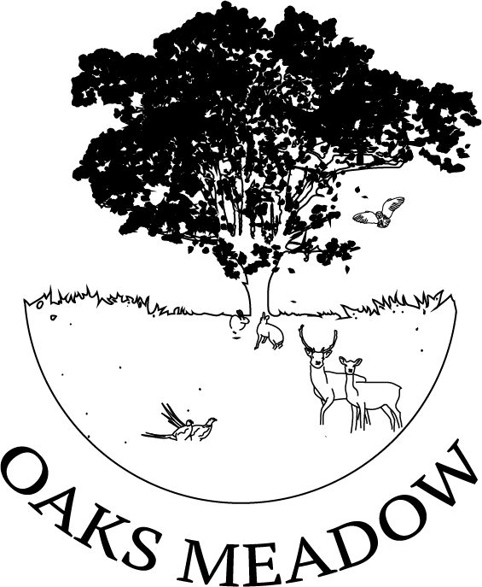

FIVE YEAR
STATEGIC PLAN
2026- 2030
Oaks Meadow Project CIO

Published November 2025

Contents
PROJECT OVERVIEW 3
OUR VISION, AMBITIONS AND VALUES 4
Vision 4
Mission 4
Ambitions 4
Our core values 4
MESSAGE FROM THE CHAIR OF THE TRUSTEES 5
ABOUT COMBS AND LITTLE FINBOROUGH 6
COMBS PARISH SURVEY 2019 7
OAKS MEADOW PROJECT VILLAGE HALL SURVEY - JUNE 2022 7
OAKS MEADOW PROJECT SURVEY - SUMMER 2025 8
OAKS MEADOW PROJECT BENEFITS TO THE COMMUNITY 9
Rebuilding a sense of community 9
Reducing isolation and loneliness 9
Health and wellbeing 9
Learning and sharing knowledge 10
Environment and biodiversity 10
STRATEGIC GOALS 12
KEY ACHIEVEMENTS (to November 2025) 13
NEXT STEPS TIMELINE 16
By end of 2026 16
By end of 2027 16
By end of 2028 16
CONTACTS AND FURTHER INFORMATION 16
NATIONAL AND LOCAL POLICY CONTEXT 17
APPENDIX 1 - Suffolk Local Nature Recovery Strategy (LNRS) (Draft April 2025) 17
APPENDIX 2 - The National Biodiversity Network (www.nbn.org.uk) 18
APPENDIX 3 - Babergh & Mid-Suffolk Joint Local Plan Part1 (November 2023) 18
APPENDIX 4 - National Planning Policy Framework (December 2024) 19

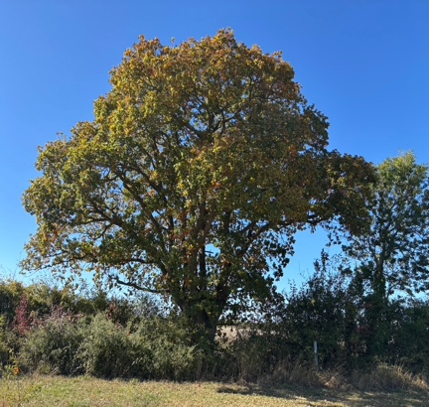
THE OAKS MEADOW PROJECT
OUR FIVE-YEAR STRATEGIC PLAN
2026 – 2030

PROJECT OVERVIEW
The Oaks Meadow Project is a charity established in 2020 following the gift of a four-acre plot of land, on a 50-year lease, for the benefit of the mid Suffolk villages of Combs, Little Finborough and surrounding areas.
The project is working with the community to create and build much-needed facilities for recreation, socialisation and education in a rural area that has no communal areas.
A survey conducted in 2019 by Combs Parish Council provided evidence of strong demand for facilities to help bring our community together and the Oaks Meadow Project is a response to that need.
The greenspace was the first part of the project and has provided a wildlife pond with jetty, a reflective space garden, a medicine wheel garden, an orchard, a sensory garden, vegetable growing plots, composting toilets and a large wooden gazebo with seating. 500 trees have been planted and 450 metres of hedging. The greenspace was designated a healing wood in 2022 by Suffolk County Council. (Suffolk Local Nature Recovery Strategy 2025 page 243)
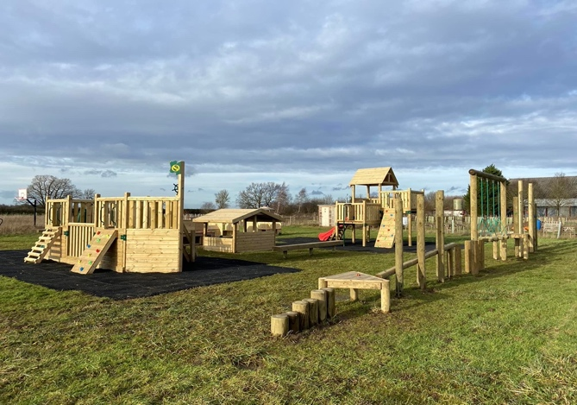
At the end of 2022 the play ground was installed with equipment to meet the needs of all ages, including exercise equipment for adults. In 2025 a football net was added and an area designated for ball games as well as the installation of swings in the play area.

At the beginning of 2025 a car park was constructed with drainage and a fence around it. This will serve, not only the meadow as a whole, but the proposed structure to provide a community hub for meetings and activities.

OUR VISION, AMBITIONS AND VALUES

Vision

To create a thriving, sustainable, and inclusive Oaks Meadow community where people, nature, and culture are interconnected and resilient for generations to come.
To provide a community area with something for everyone regardless of age or ability, with the provision of facilities for recreation, leisure and education. All in an environment that fosters learning and wellbeing where we can support each other. (Appendix 1)

Mission

The Oaks Meadow Project works to preserve natural landscapes, foster biodiversity, empower local communities, and promote sustainable practices that enhance well-being and resilience. (Appendix 1)

Ambitions
With many of the initial ambitions being achieved we can now focus on expanding the countryside experience for all and the maintenance of existing facilities. While looking to provide an indoor community hub as the last part of the initial proposals for Oaks Meadow.
- Maintain the green space with all of it’s additions and facilities and the play area.
- Identify & officially record through ‘iRecord’, common and rare species found on the meadow. Oaks Meadow is already on the map. (Appendix 2)
- Introduce educational opportunities for children including bug hunting, pond dipping, moth trapping, bird watching, foraging, plant properties & plant identification. Engaging with schools and school groups such as Home Educated children.
- Provide picnic tables around the playground area
- Introduce a Junior Countryside Club to meet regularly to learn about the countryside that they live in and to develop their own garden space.
- Build a fairy garden.
- Clear pathways on the corner mound for adventure play.
- Develop an arena beyond the corner mound for outdoor activities.
- Create stumpery gardens with the large bare roots on site.
- Construct a community hub as a place where people can meet to pursue group interests that they enjoy and provide community services as well as regular events for all ages.

Our core values
- Community Engagement - Collaborative planning and decision-making. We are community-led and welcome longstanding residents and newcomers alike.
- Equity & Inclusion – We believe everyone has a role to play, should they wish, regardless of age and ability in helping to create and maintain the facilities, ensuring benefits for all members of the community.
- Sustainability –Long-term stewardship of land, people, and resources. We seek to enhance the natural environment to encourage and protect wildlife, and mitigate the effects of climate change wherever we reasonably can. We will promote sustainable ecosystems and recycling with a view to providing education and conservation of local flora, fauna and the environment generally.
- Accountability – Transparency in goals, actions, and impact.
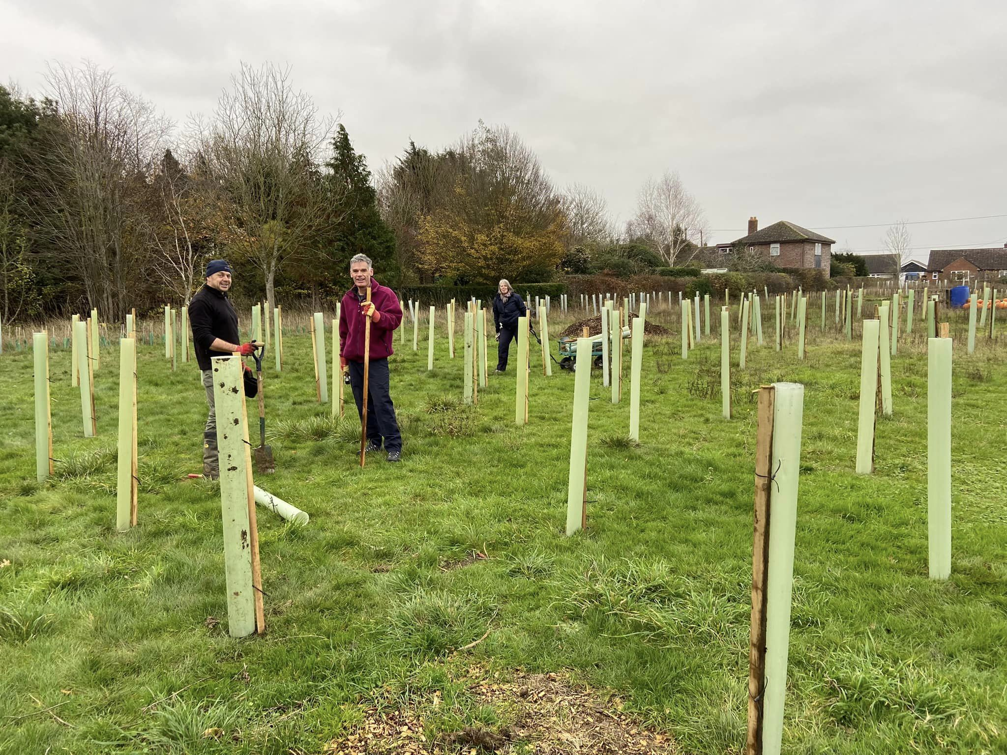

MESSAGE FROM THE CHAIR OF THE TRUSTEES

Over the years Combs has lost all facilities including the village school, the Post Office and shop, the Live and Let Live and the Gardeners Arms pubs. Little Finborough has never had any amenities. This left our community with no indoor or outdoor facilities in which to gather together and socialise.

Oaks Meadow, once part of Fenn’s Farm, was transferred to me by Victor and Daphne Scarff in 2005. The village fete was held there for 11 years as was the occasional celebration, such as the Combs village school reunion and maypole dancing, but otherwise the meadow had stood bare and desolate. It has been my privilege to lease this meadow to the Oaks Meadow Project to provide a lasting legacy to the villages for future generations and to reduce our carbon footprint by doing our bit to offset climate change.
The Covid lockdowns showed us how important strong communities are and how much people value local green spaces. Oaks Meadow fits well with that spirit of community revival.
An original concept plan produced at the beginning of 2021 was soon acted upon with the help of local volunteers and in collaboration with a range of organisations. To date this has resulted in the planting of woodland and hedges, a wildlife pond, gardens for quiet reflection and appreciation of flora that abounds in the countryside. A beautiful orchard yielding a variety of fruit and a welcome to Wild Heritage Suffolk who are managing the vegetable beds. The playground is appreciated by all the children and young people in the village as well as their carers who now have somewhere to take them for recreation and outdoor activities.
As we are moving into the next five years of the project there is much to do, with the major part being the proposed construction of a community room//hub with kitchen and toilets. All being well, when the next five-year plan is written in 2030 we hope the room will be on the meadow and well used.
If you would like to know more or if you feel you can support this exciting community-led project through funding, joining our volunteer teams or in any other way, we would be delighted to hear from you.
Desiree Shelley
oaksmeadow@gmail.com
www.oaksmeadow.org.uk
Facebook: oaks meadow project

ABOUT COMBS AND LITTLE FINBOROUGH
The Parish of Combs is in mid Suffolk, south of the market town of Stowmarket. The Parish’s population is 974 (ONS Parish Population estimate 2021) and includes the rural villages of Combs and the hamlets of Moats Tye and Little London. Little Finborough is a small neighbouring village with a population of approximately 57 (excluding minors, Electoral Register 2019-20) .
The villages have no community indoor or outdoor amenities, shop(s), pub or café. The Battisford and District Cricket Club in Moats Tye is a member’s sports club and the recently opened Burnt House Vineyard Cellar Door has limited opening times. The combination of these factors and a dispersed, ribbon development make it difficult for people, particularly newcomers, to meet and identify as a community.
The population of the village has steadily increased over recent years.
Year | 2001 | 2011 | 2021
Population | 759 | 852 | 974
(UK ONS)
Age breakdown for Combs Parish (ONS 2021)
Age group | Number | Percentage
0 to 9 | 59 | 6.1
10 to 19 | 67 | 6.9
20 to 29 | 73 | 7.5
30 to 39 | 89 | 9.1
40 to 49 | 85 | 8.7
50 to 59 | 185 | 19
60 to 69 | 222 | 22.8
70 to 79 | 146 | 15
80+ | 48 | 5
Total | 974 | 100%

Combs and Little Finborough estimated population mid-2020
Age group | Number | Percentage
0-15 | 154 | 13%
16-64 | 761 | 62%
65+ | 305 | 25%
Total | 1220 | 100%
Suffolk Observatory mid-year population estimates

COMBS PARISH SURVEY 2019
The vision and ambitions of the Oaks Meadow Project are closely aligned with the results of a comprehensive 2019 survey conducted by Combs Parish Council. Some of the key findings are extracted below:
While the majority of people who responded (one third of households) plan to stay in the area a significant number were thinking of leaving because of:
- a lack of village facilities
- no village hub
- worries about health and old age.
The respondents told us that the top three village improvements the community would like to see are:
- heritage tree planting
- community space to sit and meet
- a play area for young children.
To date the Oaks Meadow Project has addressed tree planting, a community space and a play area. Now is the time for us to turn to a community hub in the shape of a structure that will accommodate undercover activities all year round.

OAKS MEADOW PROJECT VILLAGE HALL SURVEY - JUNE 2022
The survey asked for resident’s views on building an eco-friendly, energy-efficient village hall on Oaks Meadow and how it might be used. It was in response to the 2019 Combs Parish Council survey, which highlighted concerns about the lack of a village hub /community space.
Survey results
The total 81 household responses received from Combs, Little Finborough & Battisford were lively and enthusiastic, with some common-sense caveats. The results were a fascinating and inspiring read with lots of terrific ideas. We were particularly struck by the enthusiasm for activities that link with the Oaks Meadow green spaces and initiatives related to health and wellbeing and helping our community to adapt to climate change, such as learning to cook more plant-based foods using produce from the OM vegetable garden.
During a meeting to review the survey results, the Trustees concluded that this is not the right time to make a firm decision and that we should review our position again in a year to 18 months’ time.
In February 2025 the Oaks Meadow User/Focus Group met and a request was sent to the Trustees to reconsider a structure on the meadow to be used as a community hub, more of a community room with kitchen and toilets rather than a village hall.
The Trustees discussed this in March 2025 and a decision was made to explore the options for such a community facility.
As always, the Trustees will ask local residents their thoughts on the proposal and what they think such a facility could be used for and if indeed they support it and will use it themselves.

OAKS MEADOW PROJECT SURVEY - SUMMER 2025
Following on from a meeting with the MSDC Planning Department and discussions with Community Action Suffolk we were asked to undertake a survey of local residents and visitors to Oaks Meadow to gauge public opinion if they would like to see a community room constructed on the meadow. This time we have had responses from 84 households in Combs & Little Finborough representing 166 adults and 42 children and a further 51 household responses from visitors in and around Stowmarket representing 101 adults and 95 children.
To the question “If a community room with kitchen and toilets was constructed on Oaks Meadow do you think it would be a good idea?” Combs and LF Residents: 73 households Yes 6 households No Visitors: 49 households Yes 1 household No

To the question “If a community room with kitchen and toilets was constructed on Oaks Meadow would you want to book it for an activity/social occasion etc.?” Combs and LF Residents: 50 households Yes 21 households No Visitors: 44 households Yes 5 households No
Subsequent questions asked what they would like to book the room for and what activities they would like to see organised within the room. The list is diverse and extensive and illustrates the need to have accommodation in the villages for smaller events rather than the larger village halls that are in the area.
A project group has been formed with residents, Oaks Meadow Trustees, Wild Heritage Suffolk representative, User Focus group members and our District Councillor, to look at the type of room that would best suit the needs of the residents. A business plan will be produced and costings for the project will be identified as well as potential funders.

Survey summary document available on the website www.oaksmeadow.org.uk

OAKS MEADOW PROJECT BENEFITS TO THE COMMUNITY
The benefits are multi-faceted and include:

Rebuilding a sense of community
The provision of indoor and outdoor spaces where we can gather together for classes, projects, social activities and celebrations will help to increase community cohesion. These facilities will enable people to do more in their own village, make new friends and be aware of and receive support should they need it.
Our project is community led and will, in large part, be delivered through the efforts of local people. We already have a strong body of volunteers of all ages who are giving their time and talents in a wide variety of ways from planning and fundraising to tree planting, grounds maintenance and plumbing.

Reducing isolation and loneliness
In dispersed rural populations such as ours there is a risk that people, particularly the elderly, may lose human contact almost entirely. Tighter-knit, more cohesive communities reduce isolation.
A growing body of research suggests that social isolation is damaging to both physical and mental wellbeing. Public Health England says that loneliness can increase the risk of premature death by as much as 30 per cent. A major barrier to social connection for many people in rural areas is simple physical isolation. One crucial step to fighting loneliness is what the national campaign to End Loneliness calls ‘gateway services’. These are opportunities created within the community for older or vulnerable people to develop new social connections, enhance face-to-face relationships and be part of a real and identifiable community of neighbours.

Health and wellbeing
These benefits encompass both physical and mental health and wellbeing. The green spaces provide opportunities for healthy outdoor activities both in the planting and maintenance of the woodland and gardens and in the ongoing enjoyment of them as places to walk, play, relax and take part in outdoor projects and events. Wild Heritage Suffolk will be taking referrals from local GP practices for those who need support with their mental health. Social Prescribing, as it is known, is a non-clinical service that connects individuals to community resources and activities such as gardening and volunteering.
A community hub structure would provide facilities for indoor health and fitness activities such as yoga and Pilates. Special interest groups and social gatherings would enable people of all ages to feel part of a caring community where people help and support each other.

Learning and sharing knowledge

There is a strong learning element to our project. Many people have lost touch with the land and the project aims to help children and young people, in particular, to understand where their food (and some medicines) come from and how they are grown and used. Wild Heritage Suffolk are overseeing the vegetable garden beds and will be offering their Let it Grow programme in 2026. Ongoing plans include a grow to eat programme where a kitchen on site will be essential and a pizza garden where the ingredients for a pizza will be grown and then cooked in an onsite pizza oven.
We are lucky to have a large site which enables us to get local schools, colleges and educational groups involved with, where appropriate, a dedicated area of land they can design, plant and tend themselves.
The provision of a community hub structure would have the obvious benefits of enabling a wide range of learning events and classes, for people of all ages and abilities, to take place within the community. As part of the 2025 survey respondents listed a number of informative activities that they would like to participate in, for example local history talks, environmental presentations, gardening talks and seasonal cookery classes.

Environment and biodiversity

The Oaks Meadow natural environment is being enhanced with the planting of new woodland, orchard and gardens and the establishment of the wildlife pond. With a four-acre site we are able to increase biodiversity and create spaces where wildlife can thrive alongside areas for public recreation. Our qualified Field Teacher (ex RSPB) volunteers on the meadow regularly and is officially recording all the insects and mini creatures that are found around the site. Several rarities have been found and this is putting Oaks Meadow on the national map of environmental success.
Green spaces serve important societal functions with unlimited economic value. For example, as well as contributing to health and wellbeing, woodlands absorb pollution and lock up carbon which in turn cleans our air. These functions benefit rural societies as a whole and help reduce costs on wider communities and local authorities.
(See Appendix 1 - Suffolk Local Nature Recovery Strategy)

COMMUNITY INVOLVEMENT
Phase 1 and Phase 2 of our original project plan was achieved mainly through the efforts of our dedicated community volunteers. They represent people of all ages and backgrounds and bring a formidable range of experience and skills. They continue to support the project in many ways including:

- As trustees, members of the User Focus Group and members of the newly formed Project Group.
- Organising and taking part in engagement activities to ensure our project is community led at every stage
- Fundraising and financial management
- Participating in working parties to clear, prepare, plant and maintain the land
- Guardians of specific areas – the orchard, reflective garden, the pond, medicine wheel garden, sensory garden and the playground area and equipment
- Service tasks – plumbing, carpentry and general site maintenance
- Advising on landscape, horticultural and woodland management
- Developing our site designs and planting plans
- Advising and handling planning and regulatory matters
- Project management and health and safety and risk assessment.
- IT support maintaining the website
- Public Relations using social media and producing promotional material
- Leading events or activities on the meadow
- Attendance at events organised by Oaks Meadow.
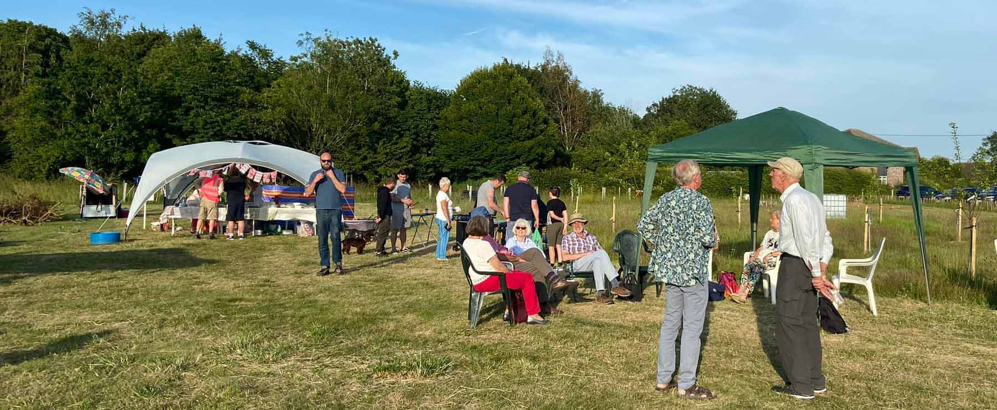

STRATEGIC GOALS
GOAL 1 Management, systems and people
Ensure we have effective management and operational structures in place together with supporting systems and policies.
Ensure we have the right people and skills when they are needed and that, whether volunteers or paid service providers, they understand their responsibilities and have the support they need.
GOAL 2 Stakeholder engagement and communications
Consult with stakeholders, including our community, on an ongoing basis to gather feedback and ensure that our project continues to meet local needs.
Ensure our stakeholders are kept informed as our project progresses both of developments and needs.
GOAL 3 Fundraising and financial sustainability
Raise the funds we need to deliver our plans through a mix of community, corporate, major donor and grant-based fundraising.
Ensure our project is financially sustainable and will continue to deliver benefits into the long term.
GOAL 4 Design and planning
For the final phase of the project, prepare or commission site plans and designs as well as fully-costed project proposals including, where appropriate, feasibility studies.
Obtain planning permissions as needed and ensure all necessary regulations and safety standards are met.
GOAL 5 Delivery
Deliver the additional ambitions to the green space of the meadow while maintaining everything that has been delivered thus far.
If it has been agreed to pursue the construction of a community room with kitchen and toilets, to deliver said construction.
See Appendix 1 for the local and national policy context.
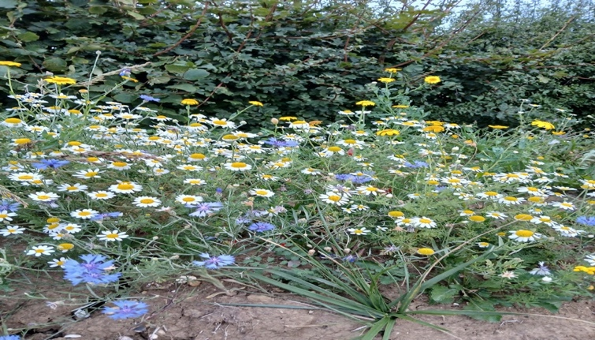

KEY ACHIEVEMENTS (to November 2025)
- Planted 500 trees and hedging plants, being recognised as a Healing Wood by SCC.(LNRS page 260)
- Mown pathways around the green space to provide adventurous walks around the site.
- Dug a wildlife pond, built a jetty, planted reeds and other water plants in the pond and prepared an area around the pond to sow pond edge wildflower seeds.
- Installed composting toilets.
- Planted an orchard with original species of apples, plums, pears, cherries, greengages and three Catherine apple trees that were first discovered in Combs. (LNRS page 113)
- Welcomed Wild Heritage Suffolk onto the site to take over the vegetable plots, to grow vegetables, fruits and other plants as part of their ‘Let it Grow’ programme.
- Designed, landscaped and planted out the reflective space garden with seating and a water feature. Constructed a dead hedge around the perimeter.
- Installed a pedestrian bridge, new vehicular access, gates and subsequently a 20-space car park.
- Installed 4 benches, made from recycled plastic, around the site
- Installed an oak framed noticeboard, a Healing Wood welcome sign and two name signs at the vehicular entrance.
- Created a bug and hedgehog house, and a purpose-built bug hotel.
- Installed a five metre wide gazebo with seating.
- Installed a range of play equipment to suit all ages and exercise equipment for adults and children.
- Held themed events to raise funds including an Easter Egg Hunt, Halloween Evening, Teddy Bears Picnic and Autumn Apple Pressing.
- Conducted a comprehensive survey to gain local views on how Oaks Meadow is perceived by local residents and visitors to the site. Also to gauge opinion of the construction of a community hub and how it could be used.
- Landscaped a Medicine Wheel Garden and added compass point poles, gravel pathways, old stump centre piece, painted stones, wooden logs and planted appropriate medicinal plants in each section.
- Recorded different insect species found on the meadow with a national register
- Organised educational sessions with school aged children. (Appendix 1)
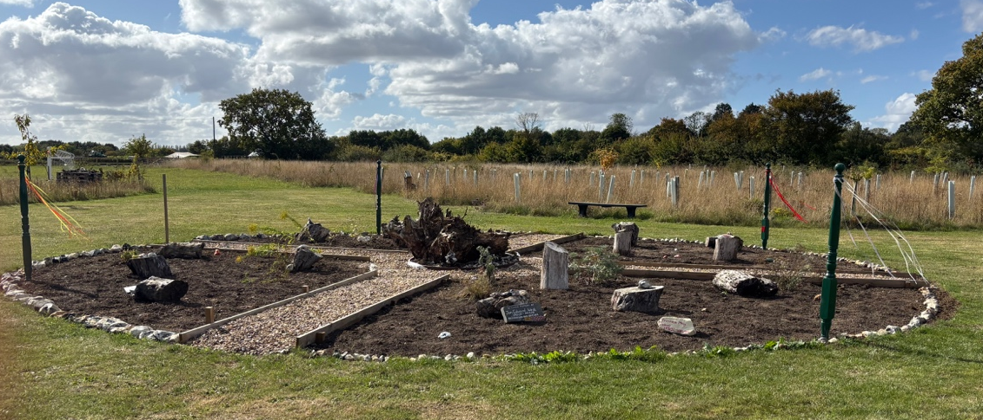

The Oaks Meadow Project is extremely grateful to all those listed below who have funded and supported the development from the initial vision in 2020 to date.
Arnold Clark Car Dealership and Geoffrey Burton Trust | Funding for an oak pedestrian bridge
Autism and ADHD Organisation | Design and creation of an area in the reflective space
Combs Parish Council | Funding for oak entrance gates, planning applications, car park drainage, swings and annual running costs.
Co-op Community Fund | Funds to go towards the installation of the Medicine Wheel Garden
Higgidy Family Kitchen | Grant to support our vegetable garden
Hoare Trustees of the Clasped Hand Trust | Wildlife pond funding
Indigo Opportunities | Regular attendance to maintain areas in the green space and sensory garden
National Garden Scheme | Funding for archways and plants in the reflective space
National Lottery Community Investment Fund and Ikea | Grant towards landscaping the reflective space
National Lottery Community Fund | Funding for the composting toilets
Mid Suffolk District Council | Third party contribution funding towards the play area and gazebo. CIL funding for the car park.
MSD Councillor John Matthissen | Locality budget funding for cycle stands, goal post and net, swings
Sicon Foundation | Supplying trees and helping to plant the community orchard
Suffolk County Council (Healing Woods) | Funding for trees and hedges, benches, signage and professional design of the reflective space | Locality budget funding (Councillor Kay Oakes)
SC Councillor Kay Oakes | Locality budget funding for a water feature
Suffolk New College – Suffolk Rural | Student participation through supervised working parties
The Art of Salvage – Danny Bellamy | Construction of the Jetty, Footbridge, Noticeboards & Entrance Fencing
Thrive at the Mix | Student involvement in various projects including making hedgehog hotels and bug houses
Valencia Communities (Viridor Credits / Landfill Communities Trust) | Funding for the children’s play area and gazebo

NEXT STEPS TIMELINE
By end of 2026 | Have a detailed business plan for the construction of a community room. Obtain planning permission and complete site requirements for a new construction. Identify funding sources and complete a financial budget for this part of the project.
By end of 2027 | Community room completed and ready for use in the next year. Form a management committee for the room to oversee the running of the room and the maintenance. To promote and organise bookings and to arrange events in the room liaising with the User Focus Group.
By end of 2028 | Assess the use of the room in it’s first year of operation. Gauge public opinion and listen to suggestions.

CONTACTS AND FURTHER INFORMATION
If you are interested as an individual, company or not for profit group, club or organisation in getting involved with the Oaks Meadow Project, please don’t hesitate to get in touch.
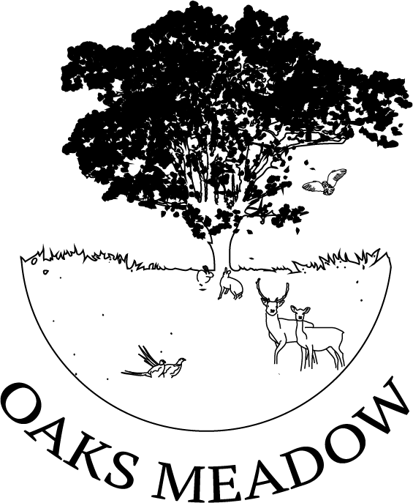
Desiree Shelley
Oaks Meadow Project Lead and Chair of the Trustees
Email: oaksmeadow@gmail.com
Facebook: Oaks Meadow Project
Website: www.oaksmeadow.org.uk
To add your name to our email updates list, please contact us as above.

NATIONAL AND LOCAL POLICY CONTEXT
The Oaks Meadow Project aligns with local and national policies, as given in the appendices below.

APPENDIX 1 - Suffolk Local Nature Recovery Strategy (LNRS) (October 2025) (suffolk.gov.uk/planning-waste-and-environment/local-nature-recovery-strategy)
The strategy outlines a plan for how everyone in Suffolk from individuals, local
communities to landowners, local governments, businesses, and national agencies
can come together to better restore nature through planning and on-the-ground action.
For everyone in Suffolk the LNRS will:
- inform how all public authorities in England meet their legal duty to conserve and
enhance biodiversity, through land management and regulatory decisions.
- seek to enhance the positive effects of nature on community wellbeing that
contribute to improved mental and physical health, including direct and indirect
benefits like clean air, water and food
- help identify key areas within the local community to prioritise nature recovery
efforts while fostering community ownership at various levels, from nest boxes to nature reserves, so everyone can get involved provide potential locations for initiatives
aimed at creating and enhancing habitats
- aid in aligning local and neighbourhood plans and other spatial strategies with
countywide objectives, and informing priority actions in future plans
- support funding applications for nature recovery projects
- encourage local community groups focused on nature recovery.

Table 1c.(Page 86) Co-benefits of nature recovery actions for cultural services (environmental settings that enable cultural interaction and activity)

- Supporting physical and mental wellbeing - Evidence that nature-rich green spaces can improve human physical and mental health and wellbeing and can have wider socio-economic benefits. For example, interaction with nature can improve a range of
health conditions including heart and lung health, high blood pressure, diabetes, immune function, depression and anxiety.
- Interaction with nature - Formal and informal positive nature-related activities, balanced with accessibility and human impacts on nature eg bird watching.
- Recreation and leisure - Provision of green and blue spaces used for any leisure activity, linking to target to ensure everyone has access within 15-minute walk.
- Aesthetic value and tranquility - Provision of views, surroundings and inspirational experiences –linked to artistic expression and creation.
- Education and knowledge - Opportunities for formal and informal education, scientific research, citizen science, local knowledge sharing, volunteer and career
opportunities.
- Community and sense of place - Aspects of an area promoting special and distinctive features – characteristic species, habitats and landscapes, alongside physical, social, spiritual or emotional importance.

APPENDIX 2 - The National Biodiversity Network (www.nbn.org.uk)
The National Biodiversity Network (NBN) is a collaborative partnership created to exchange biodiversity information. The NBN Trust, the charity which oversees and facilitates the development of the Network, has a membership including many UK wildlife conservation organisations, government, country agencies, environmental agencies, local environmental records centres and many voluntary groups.
THE NBN ATLAS
The NBN Atlas is the UK’s largest repository of publicly available biodiversity data. It brings together the data from multiple sources and makes it available and usable online. The NBN Atlas is at the heart of the data flow for nature’s recovery.
MAKING THE MOST OF BIODIVERSITY DATA
Biodiversity data about plants, animals and fungi and their habitats may be used to educate and inform and in environmental decision-making, state of the environment assessments and restoration and rewilding.

APPENDIX 3 - Babergh & Mid-Suffolk Joint Local Plan Part1 (November 2023)
LP16 - Biodiversity and Geodiversity (Page 71)
15.14 Green infrastructure refers to a network of spaces and linkages that are generally
valued for their wildlife, geological, landscape or historic importance and may also have recreational value and help reduce flood risk. Although often important in their own right, when considered as a holistic network they provide much greater benefits. Emphasising the importance of green infrastructure creation, protection conservation and enhancement, ensures an improved and healthy environment that is available for present and future communities.

LP28 - Services and Facilities Within the Community
16.01 The aim of the policy is to support and safeguard key services and facilities within the Districts, which play an important role within the community.
16.03 For the purpose of this policy, community services and facilities include: open spaces, village and public halls, community centres, places of worship, cinemas, theatres, libraries, leisure centres, museums, public houses, restaurants, cafés, convenience shops, banks, building societies, and post offices.
16.04 Open spaces includes:
a) Allotments which are valuable community spaces and offer people opportunities for
food production;
b) Amenity green space (defined as spaces which are open to free and spontaneous use by the public but are not formally managed for a specific function such as a park or playing field; nor managed as a natural or semi-natural habitat, and for the purposes
of open space provision are considered to be greater than 0.15 ha in size);
c) Sports and recreational facilities which include, but are not limited to, parks and
gardens, outdoor sports facilities, play spaces and formalised sports clubs’ space
(such as playing pitches and golf courses); and
d) Accessible natural green space which covers a variety of partly or wholly accessible spaces including meadows, woodland and copses of trees all of which share a trait of having natural characteristics and wildlife value, but which are also open to public use and enjoyment.

APPENDIX 4 - National Planning Policy Framework (December 2024)
Section 8 Promoting healthy and safe communities

96 Planning policies and decisions should aim to achieve healthy, inclusive and safe

places which:

a) promote social interaction, including opportunities for meetings between people

who might not otherwise come into contact with each other – for example through

mixed-use developments, strong neighbourhood centres, street layouts that allow

for easy pedestrian and cycle connections within and between neighbourhoods,and active street frontages;

c) enable and support healthy lives, through both promoting good health and

preventing ill-health, especially where this would address identified local health

and well-being needs and reduce health inequalities between the most and least

deprived communities – for example through the provision of safe and accessible

green infrastructure, sports facilities, local shops, access to healthier food, allotments and layouts that encourage walking and cycling.

98. To provide the social, recreational and cultural facilities and services the community needs, planning policies and decisions should:
(a) plan positively for the provision and use of shared spaces, community facilities (such as local shops, meeting places, sports venues, open space, cultural buildings, public houses and places of worship) and other local services to enhance the sustainability of communities and residential environments

Open space and recreation
103. Access to a network of high quality open spaces and opportunities for sport and
physical activity is important for the health and well-being of communities, and can
deliver wider benefits for nature and support efforts to address climate change.
Planning policies should be based on robust and up-to-date assessments of the
need for open space, sport and recreation facilities (including quantitative or
qualitative deficits or surpluses) and opportunities for new provision.

Section 15. Conserving and enhancing the natural environment
187. Planning policies and decisions should contribute to and enhance the natural and local environment by:
a) protecting and enhancing valued landscapes, sites of biodiversity or geological value and soils (in a manner commensurate with their statutory status or identified quality in the development plan);
b) recognising the intrinsic character and beauty of the countryside, and the wider benefits from natural capital and ecosystem services – including the economic and other benefits of the best and most versatile agricultural land, and of trees and woodland
