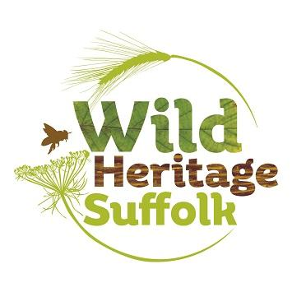
Activity Report

Oaks Meadow AGM

Year to November 2025

This last year has been a time for bedding in in terms of our physical presence on the Meadow, developing a business plan for the next 3 years and updating the organisational support structures such as the website, the domain, banking arrangements and some of the formal requirements of our CIC status.

On the Meadow

The development of the Wild Hut as our centre on the Meadow has been a main focus and the provision of some drought resilience in the form of rainwater capture from the roof. We installed guttering and 3 IBC’s to store the runoff which are now full. Time will tell whether 3 will be sufficient but there is space to add further storage if needed.

We are pleased that this also provides another covered space for use by other groups and events on the Meadow.

We are also keen to develop accessibility generally on the site and as a first stage we installed a wheelchair ramp from the carpark to the field. In addition, Oaks Meadow has had a donation of patio slabs which we were grateful to accept and will use to pave around raised beds that are accessible for wheelchair users. In time, installation of ground mesh to link areas within the project are envisaged as well as across the site.

Events

We held our first event in October which was Apple Pressing Day made possible by the generous donation of time and equipment by Steve Adams, a former director of Wild Heritage Suffolk. The weather held - just! - and thanks to the local advertising by the Oaks Meadow Trustees we had a great turnout. This was a chance to introduce ourselves to the community and talk about what we provide and future offerings.

Business Plan

The current core offering is the Let it Grow course, a 12 session provision for those taking advantage of social prescribing. Participants are supported to grow their own flowers, fruit and veg seeing the process through from seed to harvest. The outside activity, learning and practicing skills as well as forming trusting relationships within the group all combine to produce a sense of achievement physically and emotionally and feedback from the past 2 outings has been universally positive. The funding round opens this month so we will be looking to secure grants of around £20k to put on the next course in May 2026.

A second income raising string will be the holding of rural and horticultural craft sessions using experienced tutors to provide learning and practice and help attendees to have a finished product to take away from the day. Our horticultural lead, Emmie Stocking, is a master composter and permaculture practitioner and will also be giving talks and demonstrations on these topics.

We are also recruiting volunteers and will be advertising volunteering days very shortly with a focus on a particular task each time.

We will also be asking the local community what they would like to see put on within our remit so we can tailor our activities to local need.

Organisation

Beyond the volunteers we are also looking to recruit more local expertise and directors. An updated webpage - ‘Work With Us’ - details all the options and details around these roles. We are currently putting together copy for social media platforms for additional reach as well as pursuing personal contacts. If you know of someone who might be interested in a role that makes use of their skills and experience please point them our way!

We are also pleased to be transferring our banking to Unity Trust Bank as it is organisation that more closely matches our community values.

Richard Bergson
Director

