The consultation will be open for your comments until April 11th 2026
If you prefer to complete online please
download the form from the website and send to
omcommunityroom@gmail.com

Once collated the results will be posted on the website
www.oaksmeadow.org.uk

If you would like to be kept informed of the progress of this project please provide an email address below.

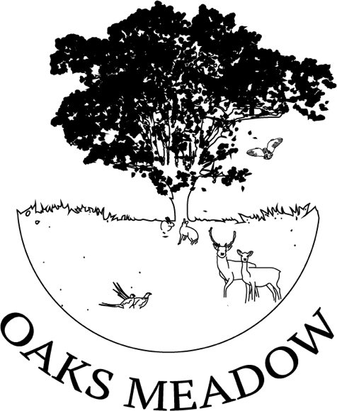

CONSULTATION RESPONSE
FOR

THE OAKS MEADOW
COMMUNITY ROOM

VIEWING OF PLANS
MARCH 28TH & 29TH 10:30-4:30
THE SHED, FENNS MEADOW
BILDESTON ROAD, COMBS, IP14 2JZ
Or on the website www.oaksmeadow.org.uk

Name: Date:

- Which is your preferred concept plan option?
Option 1 [ ]
Option 2 [ ]
Option 3 [ ]

- What do you like about your preferred option?

- Is there anything you would change with your preferred option?

- Additional comments or observations about your preferred option.

- Looking at the finishes on poster 4, what would you like to see on your preferred option for
Sides:

Roof:

Entrance:

- Are the facilities adequate in your preferred option?
YES / NO

- If NO what would you like added?

- If this community room was constructed would you like to hire it? YES / NO

- If you answered yes to 8 what would you want to hire it for?

- Is there anything else you would like to add or comment on?
(continue on an extra sheet if needed)

